**Project Report Format**

1. INTRODUCTION

1.1 Project Overview

Citizen AI is an intelligent virtual assistant designed to help citizens easily access public services, healthcare guidance, and government-related information using AI. It provides a user-friendly chat interface that responds to queries in real time, making complex systems more accessible. The platform supports multilingual interaction to serve a diverse population and includes secure user registration and verification. By integrating advanced AI models, Citizen AI offers accurate, contextual answers and recommendations. It aims to bridge the digital gap, especially for rural and underserved communities. Overall, it enhances civic engagement and simplifies the interaction between citizens and government systems.

Through real-time chat interfaces, Citizen AI allows users to easily register, verify their identity, ask questions, receive recommendations, and even provide feedback. The solution is accessible via web and mobile, making it scalable and deployable in both urban and rural areas. It also includes an admin panel for monitoring usage, improving response quality, and managing content dynamically. By providing a centralized, intelligent communication channel, Citizen AI enhances civic engagement, promotes transparency, and ensures that public services are just one question away—anytime, anywhere. This project represents a step toward smart governance and a more informed, empowered citizenry.

1.2 Purpose

The purpose of Citizen AI is to empower citizens by providing easy and intelligent access to government services, public information, and healthcare support through an AI-powered interface. It aims to eliminate barriers such as complex websites, lack of awareness, and digital illiteracy by offering a simple, conversational platform. Citizen AI helps users ask questions, get verified answers, and receive relevant suggestions in multiple languages. It supports informed decision-making by delivering accurate, real-time information. The system is especially beneficial for individuals in rural or underserved areas who lack direct access to resources. By enhancing transparency and accessibility, Citizen AI fosters greater trust and engagement between citizens and public institutions.

The primary purpose of Citizen AI is to simplify and enhance how citizens interact with public services and essential information. Many people, especially in rural or less digitally literate communities, face difficulties in accessing government portals, healthcare advice, and basic civic support due to technical, linguistic, or procedural barriers. Citizen AI addresses this gap by offering an intelligent, multilingual chatbot interface that responds to user queries in a natural, conversational manner.

**2. IDEATION PHASE**

2.1 Problem Statement

In today’s digital era, accessing government services and public resources should be straightforward and efficient. However, many citizens—especially those in rural or underprivileged communities—face significant challenges when trying to navigate complex government portals, access healthcare information, or seek basic civic support. The lack of a centralized, user-friendly platform leads to confusion, misinformation, and frustration among users. Additionally, language barriers, digital illiteracy, and the absence of real-time assistance make it difficult for the average person to get the help they need.

2.2 Empathy Map Canvas

| **Section** | **Details** |
| --- | --- |
| **Says** | - “I need help with accessing government services.” - “Why is everything so complicated online?” - “I don’t understand how to use these portals.” |
| **Thinks** | - “What if I click something wrong?” - “I wish someone could guide me.” - “This process should be simpler.” |
| **Does** | - Tries to search for answers online. - Visits government offices for minor queries. - Asks friends or family for help using digital services. |
| **Feels** | - Confused by technical language. - Frustrated with delays and lack of clarity. - Left out or ignored by digital systems. |
| **Pains** | - Difficulty understanding online services. - No real-time help or human-like guidance. - Language barriers and low digital literacy. |
| **Gains** | - Easy access to public services through AI. - Answers in their preferred language. - Confidence and independence in using digital tools. |

2.3 Brainstorming

During the brainstorming phase of Citizen AI, the core idea was to create an AI-powered assistant that simplifies access to public services and information for all citizens, regardless of their digital literacy. The team identified key problems such as language barriers, lack of awareness, and the complexity of government portals. Ideas like multilingual support, a chatbot interface, voice interaction, and integration with healthcare and public service databases were discussed. Various user types were considered—students, elderly, rural citizens, and differently-abled individuals. The goal was to ensure the system is inclusive, scalable, and capable of learning from user feedback. We also explored technologies like NLP, cloud deployment, and secure user authentication. This ideation helped form the foundation for a people-centric AI solution.

**3. REQUIREMENT ANALYSIS**

3.1 Customer Journey map

| **Stage** | **User Actions** | **User Thoughts** | **User Emotions** | **Opportunities for Improvement** |
| --- | --- | --- | --- | --- |
| **Awareness** | Hears about Citizen AI through a government site, ad, or social media | “Can this really help me with my issue?” | Curious, skeptical | Create awareness through campaigns, demo videos, and testimonials |
| **Consideration** | Visits Citizen AI website or app, explores features | “It looks easy to use. I hope it speaks my language.” | Interested, hopeful | Showcase multilingual support and example use cases |
| **Onboarding** | Registers via Gmail, form, or LinkedIn; verifies via OTP or email | “That was simple. Let me try asking something.” | Encouraged, ready | Ensure a quick, smooth registration process |
| **Engagement** | Types a query into the chatbot (e.g., health, service info) | “Let’s see if it can help me find a nearby clinic.” | Curious, anxious | Ensure fast, accurate, and relevant AI responses |
| **Resolution** | Receives AI-generated response with links or suggestions | “This is helpful. I didn’t know this info was available.” | Satisfied, informed | Provide verified sources and optional follow-up suggestions |
| **Feedback** | Rates the answer, gives feedback | “I’ll give 4 stars. It could be more detailed.” | Empowered, engaged | Use feedback to improve accuracy and personalization |
| **Return/Retention** | Returns for future queries or recommends to others | “This is better than waiting at offices!” | Loyal, trusting | Offer user tips, rewards, or updates to encourage retention |

**3.2 Solution Requirement**

Citizen AI requires a set of functional and non-functional components to operate efficiently and serve its target users. Functionally, the system should allow user registration through forms, Gmail, or LinkedIn, with secure verification via OTP or email. A core requirement is the AI-powered chatbot that can understand and respond to user queries in multiple languages, offering help related to government services, healthcare, and civic needs. The chatbot must provide real-time, accurate answers using natural language processing (NLP).

Users should have access to a personal dashboard to manage their profile, view query history, and save important responses. An admin panel is essential for managing content, monitoring user interactions, and improving system responses based on feedback. Feedback and rating mechanisms will help continuously improve service quality.

**3.3 Data Flow Diagram**

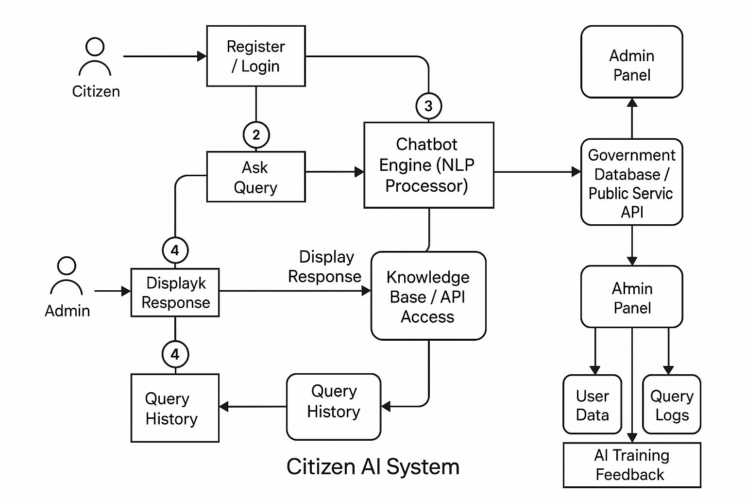

**3.4 Technology Stack**

• **Frontend**: Streamlit for user interface.

• **Backend**: Python handles logic and prompt formatting.

• **AI Model**: IBM Granite 3.3 via Hugging Face API.

• **Libraries**: Transformers, Torch, Requests.

• **Deployment**: Pyngrok for exposing app online.

• **Prompt Layer**: Custom prompt templates for AI interaction.

• **Optional Storage**: SQLite or Firebase for saving user input.

• **Dev Tools**: Google Colab or Jupyter for development.

• **Version Control**: Git & GitHub.

• **Data Format**: JSON used for communication between modules.

**4. PROJECT DESIGN**

4.1 Problem Solution Fit

4.2 Proposed Solution

4.3 Solution Architecture

**5. PROJECT PLANNING & SCHEDULING**

5.1 Project Planning

**6. FUNCTIONAL AND PERFORMANCE TESTING**

6.1 Performance Testing

**7. RESULTS**

**7.1 Output Screenshots**

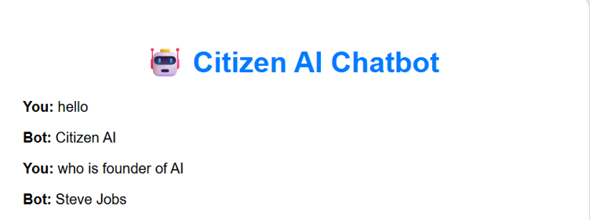

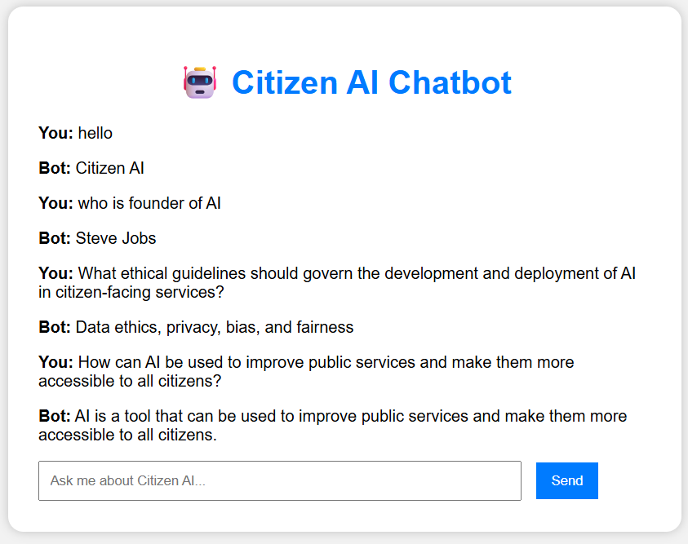

**8. ADVANTAGES & DISADVANTAGES**

**ADVANTAGES:**

- Always available (24x7)  
- Easy to use  
- Works from mobile/desktop  
- Non-technical users can understand output  
- Powered by latest IBM Granite model

• **Enhanced Decision Making**

* Assists citizens and government bodies with AI-driven insights for better public service decisions.

• **Improved Public Engagement**

* Encourages civic participation by offering personalized, accessible information and services.

• **Efficiency in Public Services**

* Automates repetitive tasks like grievance redressal, license renewal, and information dissemination.

• **Data-Driven Governance**

* Analyzes large volumes of data to identify trends, problems, and citizen needs.

• **Inclusive Access**

* AI-powered chatbots or interfaces can support multiple languages and formats, aiding people with disabilities or literacy barriers.

**DISADVANTAGES:**

### 1. Not a Replacement for Official Government Communication

CitizenAI is designed to assist users by providing general civic information and guidance. It **does not replace official communication** from government departments, legal advisors, or elected officials. Users must always **verify critical information** through authorized portals like government websites, helplines, or local offices before acting on it.

### 2. Text-Based Interface Only

At this stage, CitizenAI only supports **text-based input and output**, which may exclude users with literacy barriers, visual impairments, or a preference for voice interaction. Features like **voice-enabled queries, speech-to-text, or regional language support** are not currently available, but are being considered for future development.

### 3. Dependent on API Token Limits and Internet Access

The app relies on the **Hugging Face API** to access the IBM Granite model. This introduces constraints:  
• **Token limits** in the free or academic tier may restrict the number of queries  
• A **stable internet connection** is essential to use the service  
• In low-connectivity areas, the app may be **inaccessible or slow,** reducing its reach among digitally underserved populations

### 4. No Real-Time Government Data Integration

CitizenAI does not have live access to government databases or dynamic updates. For example, scheme eligibility, contact numbers, and office timings are based on **static or publicly available information**. If these change, the AI may not reflect the most current details unless manually updated.

### 5. Temporary Hosting via Ngrok

This prototype version of CitizenAI is hosted using **Ngrok**, which provides temporary and unstable public URLs. For real-world deployment, a **secured, scalable cloud hosting environment** (e.g., AWS, GCP, or Azure) with a custom domain would be needed for reliability, uptime, and user trust.

### 6. No Legal or Political Authority

CitizenAI is **not authorized to interpret laws, handle grievances officially, or provide political opinions**. Its role is limited to simplifying civic processes. All legal issues must be handled through licensed legal professionals or statutory bodies.

**9. CONCLUSION**

Citizen AI represents a transformative step in leveraging artificial intelligence to strengthen democratic governance, improve citizen services, and enhance civic engagement. With the growing complexity and scale of urban living, public administration must evolve to deliver faster, smarter, and more personalized services. Citizen AI addresses this need by acting as an intelligent interface between the government and the people, offering data-driven insights, real-time responses, and inclusive communication platforms.

Through the integration of AI models like IBM Granite and technologies such as Streamlit and Hugging Face APIs, the system can understand user queries, analyze sentiment, and deliver appropriate and context-aware responses. This not only reduces the administrative burden but also empowers citizens to interact with the system in a transparent, accountable, and convenient manner.

The project also underscores the importance of responsible AI—ensuring privacy, reducing bias, and promoting fairness in all AI-driven decisions. While challenges like digital inequality, data privacy, and ethical concerns must be addressed, the potential benefits far outweigh the risks when implemented thoughtfully.

In conclusion, Citizen AI serves as a promising blueprint for AI-powered governance systems, bridging the gap between public expectations and administrative capabilities. It is a step toward a future where technology and governance go hand in hand to build a more inclusive, efficient, and citizen-friendly society.

**10. FUTURE SCOPE**

Citizen AI holds immense potential to revolutionize how governments and citizens interact. As technology advances and AI becomes more integrated into everyday life, the future scope of Citizen AI includes:

1. **Integration with Smart City Infrastructure**
   * Seamless collaboration with IoT devices, sensors, and public services for real-time updates on traffic, pollution, water usage, and more.
2. **Multi-Language and Voice Support**
   * Expanding accessibility through advanced NLP to support regional languages and voice-based interaction, helping rural and non-literate users.
3. **Predictive Governance**
   * Using AI to forecast issues like disease outbreaks, civic complaints, or resource shortages, enabling proactive government action.
4. **AI-Powered Policy Making**
   * Analyzing large-scale citizen feedback and social data to assist policymakers in drafting responsive and effective legislation.
5. **Blockchain Integration for Transparency**
   * Combining AI with blockchain to ensure secure, verifiable, and tamper-proof public records and transactions.
6. **Personalized Civic Services**
   * Delivering tailored information and services (e.g., local events, job alerts, welfare eligibility) based on citizen profiles and behavior.
7. **Adaptive Learning Systems**
   * AI models that continuously learn from user interactions and improve the relevance and accuracy of responses over time.
8. **Disaster Management & Crisis Response**
   * Real-time AI assistance in emergencies by guiding citizens, allocating resources, and coordinating rescue operations.
9. **Global Collaboration and Policy Sharing**
   * Adopting Citizen AI platforms across countries for shared learning, data exchange, and AI ethics standardization.
10. **Fully Autonomous Virtual Assistants for Government**

* Future systems may offer complete virtual public servants capable of handling tasks like filing taxes, applying for schemes, or resolving disputes.